Modular Concept of a DCS-BIOS-RS485-System

Intro
The intention designing this board-family was to create a bulletproof solution for Builders of own Cockpits. The goal was a system that fits to any requirements. The whole system is based on Ians amazing DCS-BIOS.
Target audience are Flight-Sim enthusiasts with no special knowledge or options in soldering, making PCBs or those who don’t want to (or mustn't) convert their living room into an electronic workshop (As I did – and I tell you: There is no way back!).
The system is modular. It consists of one (or even more) Master-Module(s) and an arbitrary number of Slave-Modules. Each Master provides up to three Chains (Channels) of RS-485-Bus. Every Chain can consist of up to 128 Slaves (in theory). This means also it is scalable. The maximum count of slave modules (3 x 128 = 384) has still to be proven by practical experiences.
Handicraft friendly design: All boards are designed in SMT whenever possible. Smallest parts and also Trace-Widths are dimensioned to allow making PCBs and soldering parts “at home” without highly specialized tools. All prototypes are made by using Toner-Transfer with a common Laser Printer.
All of this wouldn’t be possible without the help of Ian, Warhog and many other members of the DCS-community. I shouldn't stop saying: Thank you very much!
Dear Reader. As I can’t know anything about your knowledges or intentions, this paperwork may not match to your requirements. This is just a general introduction. Some special information or data you will find in the to your special hardware dedicated papers.
Please feel free to contact the autor if there is something missing, wrong or incomprehensible. :)
Stage of Development (valid just for this document): Nov 16, 2017, tekkx@dresi.de

Master-Board
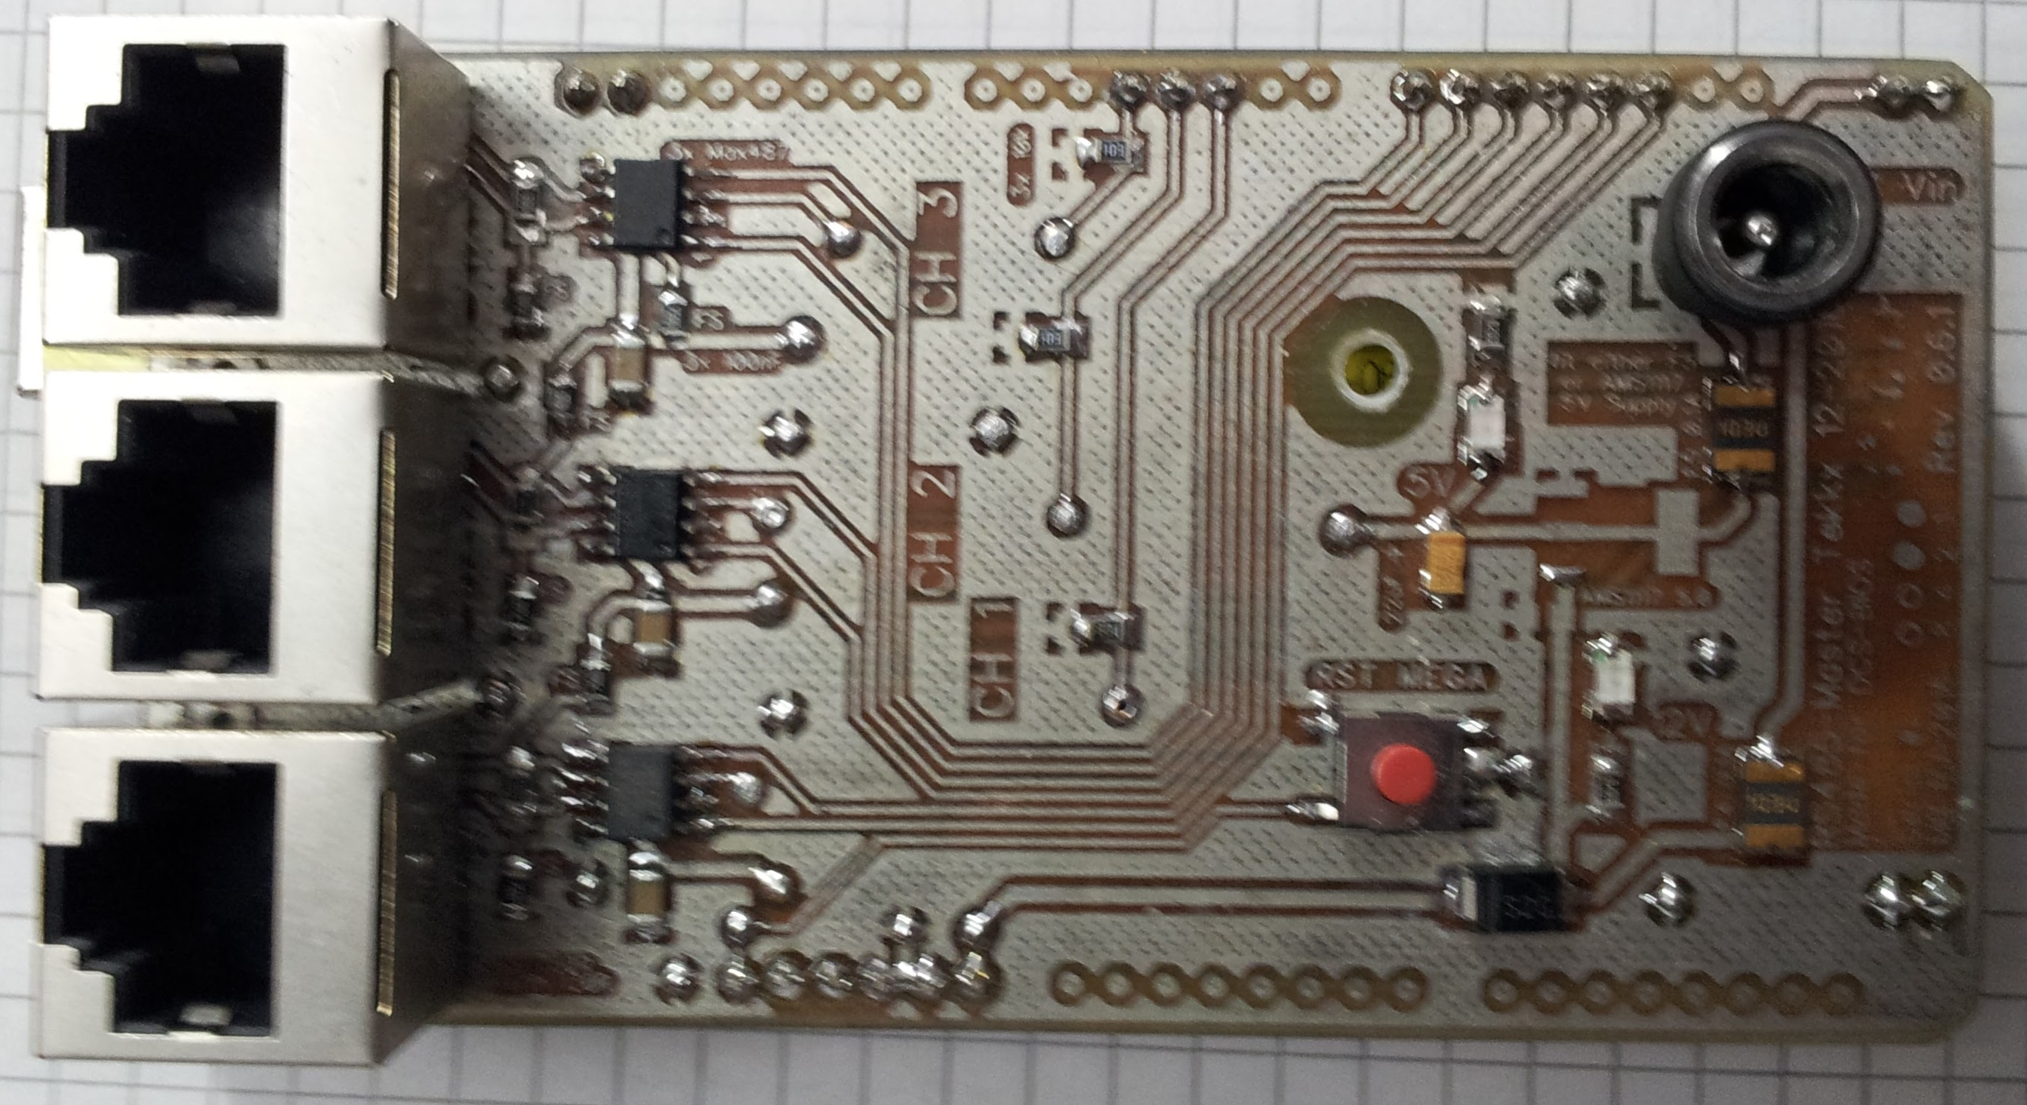
The Master Board is nothing but a special Shield for the Arduino MEGA similar to the more than 100 already available Shields for UNO, MEGA and family. If it stacked on the MEGA it brakes out three RS485-Transceivers (MAX487 or DS36276) and provides this way up to 3 Channels of the RS-485-Bus. There are also a connector (later there will be 3 of that) for a power supply for convenient power up these 3 Channels with 12 Volts, different fail-safe features and termination.

Fail-safe features are:
- TVS-Diode (SMBJ12A) of the common 12V supply circuit (TVS: Transient Voltage Suppressor) deflects high voltage peaks up to several 1000 Volts to the ground plain. This could be happen due to flash strike or rubber soles on synthetic (non conductive) flooring.
- TVS-Diodes (integrated in one SM712) for each line of the RS-485-Bus
- Self-Resetting PTC Fuses of 2.5 A for each Bus-Supply-Line
- Filter-Capacitors to decrease any noise or ripple of the Power-Lines
- Fail-safe-Bias- and Termination-Resistors on board
TVS-Diodes are under normal condition high resistance, so they bring no relevant extra load to the bus.
Master-Boards are usually delivered with a MEGA 2560 R3 (ATmega2560-16AU CH340G), so the Device has to be shown in (Windows 7) “Printers and Devices” as USB-SERIAL, CH340 (COMxx).
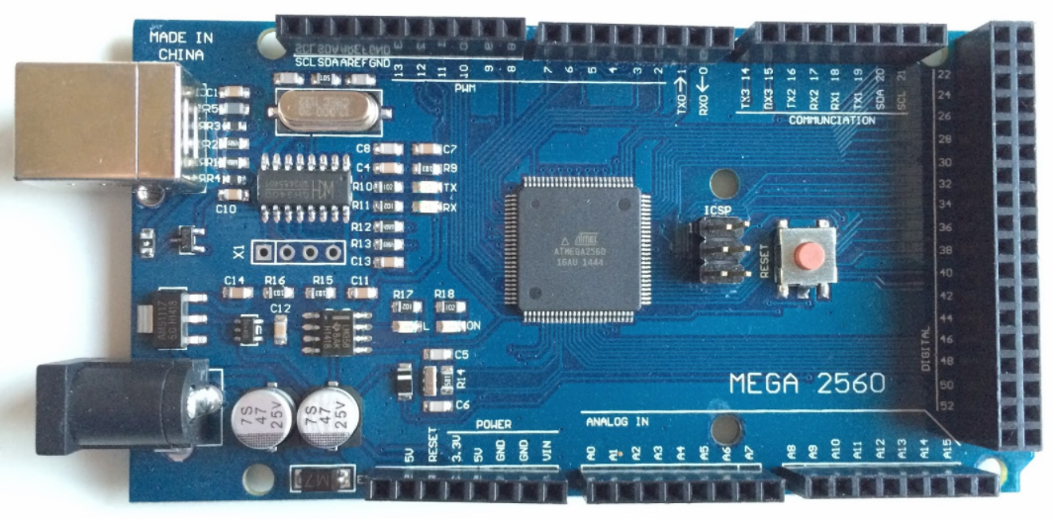
If there are some issues, look for the latest drivers for CH340 at the internet. As I believe, USB- and all related stuff is charlatanism, I can't give a helpful hint. But anyhow: I brought it to business everytime. :)
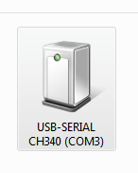

General Features
Connection to the RS-485-Bus is realized by shielded RJ45-connectors. I decided to use this kind of connection, cause the link between Master- and Slave-Modules can easily achieved by standard Cat5 or Cat6 cables. These cables are available cheap and ready-made in different lengths (and colors) up from 25 cm. So the installation will become easy and clean. It will be possible to link RS-485 and power supply for all Modules over one single cable-(Daisy-)chain without a small chance to do wrong (inverted poles are very common). An early stage of the bus layout led 5V over the Line to feed the Transceivers. Cause I've been afraid of too much Voltage drop over longer connections I decided to commit these 5V nearby every single RS-485-Transceiver. So there will the configuration of the Cat5 wiring is as follows: Two wires (twisted Pair 1) are for the RS-485, 3 Wires are for 12V and other 3 Wires are connected to Ground. Each wire (including contacts of RJ45) is safe loadable up to 1 Amp. As we use 3 of them at each Line (or Channel), there should be plenty of headroom. If you use shielded cables (highly recommended), Shield is also linked to the Ground-Level.
The unshielded printed onboard portion of the RS-485-Traces are kept as short as possible to decrease jamming the Bus by external stray radiation.
Each ICB is equipped with two RJ45s (while the MB has just one per Channel). One is to use as the Input, while the other is accordingly Output to link the next Module by a Cat5-Cable. Second RJ45 of the last Module in the Chain remains free. Here you can insert an optional special Termination-Plug. Relaxed interpreting RS-485-Specs, safe un-terminated operation should be possible up to 10 m (or 30 feet) overall bus length (before reflections will become relevant). Latest Revisions of MB has Termination and Fail-Safe-Bias fixed on-board.

Interface- and Control-Board ICB-x-RJ-yyyy-##

„-x-“ designates the special Version, „-yyyy-“ is for the year of construction, „-##“ is the running number
The ICB is essentially nothing but a break-out of the Arduino NANO. Whilst the MB is a perfect matching shield to the MEGA, the ICB can rather be seen as a platform where the NANO sit on amid some other parts. During the development many accidents are happen which consequents fail of NANOs, MEGAs, AMS1117s or MAX487s. I have many devices here in the “Chest of Remembrance” without any smoke inside (I let it all out). So there are added bit by bit some safety- and failsafe features.
Each ICB has its own stabilizer to feed just the MAX487 with constant 5,0 Volts (+/- 0,1V or less), even in the worst (even unlikely) case if the bus-power should drop down to 6,5 Volts.
Other failsafe-features are
- TVS-Diode on the 12V-Line
- special TVS-Diodes on the RS-485-Lines
- PTC-Fuses (self resetting) for Over-Current-Protection of the 12V-Line
- Pull-Down-Resistors of 10k on each TX-enable-Pin. The intended purpose of these Pull-Down-Resistors is to prevent undefined state while start up the system or hot-plug individual modules. These Resistors unfortunately bring potentially an additional load to the RS-485-Bus. So maybe the theoretical Chain-Length of 128 Nodes won't be reached without issues (still under investigation).
The power supply of each ICB is provided by the Main Bus. Each of the three Chains can be lade with 2 Amps safe. Additional each ICB is equipped with a 5mm female Jack. There can optional an extra supply connected if some „heavy“ consumers (as coils, motors, screens, incandescent bulbs...) are connected to the board. This additional supply is discrete (decoupled by a Schottky) from the Main-Bus. So the external 12V in-feed supports just the consumers at this single Module. This reliefs the Main-Bus and keeps the impact of heavy loads away from the Bus.
All ICBs are equipped with two RJ-45 receptacles: One is as Input, the other one is as Output. And it doesn’t matter, which one is used for what.
All versions are equipped with a Potentiometer for trimming intensity of PWM-controlled Backlight. It works the analog way by reducing base-voltage of the PWM. This is for matching brightness of different Panels. This Pot is only to actuate by means of a small Screwdriver if the related module is lift off the DZUS-rail.
Backlight-Trim limits the maximum power rate of the Backlight to 1 (one) Ampere.
Basic Design of all ICBs aims to be standardized to almost all applications. All ICBs come at the same size and same mounting holes. They are designed to easily fit into any Panel designed according to DZUS-Rules.
While the RS-485 and the PWM-Backlight at the Slave-Modules needs to be controlled, some I/O-Pins aren’t available:
- Pins D0 and D1 are occupied by the TX- and RX-Lines,
- Pin D2 is for enable the TX,
- Pin D3 is used as PWM-Out for controlling the Backlight.
Whereas all ICBs are to connect by RJ-45, there are offered some different versions which are specialized for different applications:

ICB-S-RJ-yyyy-##

“S” for Single Arduino.
This is the board for most common applications. All digital and analog I/Os are serviceable. Except D2 and D3, these are already used for RS-485 and PWM-controlled Backlight. Both functions are hard connected on the PCB to either the MAX487 or the MOS-FET.
The digital I/Os D4 to D13 and the analog INs A0 to A7 (some versions don’t use A7) are each broke out on a 10-Pin male pin header. While developing a Lightboard for the SAS-Panel it came out as a benefit to rearrange some analog Pin-Outs to easily connect a Potentiometer (5V / analog IN / GND) without to crossover the connecting cable.
Also there are two (up to)10-pin-headers with alternating 12V-GND or 5V-GND for different purposes.
By means of temporarily removing Jumper “RX/RE” can the Transceiver be disconnected for uploading a new sketch to the AVR without the imperative removing the Arduino from the board. Meanwhile I upload all sketches by ISP. For this I converted an Arduino UNO as a Programmer. One of the benefits of this course of action is, if uploading many sketches to many different AVRs, the Programmer is always on the same serial port and I don't have to look for, where the actual AVR is :)
All ICBs (up from Rev 0.8.0) are equipped with a Test-point (TP) where RX, TX and TXenable are broke out for easy connecting a Logic Analyzer if Troubleshooting is required.

ICB-T-RJ-yyyy-##

Double Arduino, “T” for TFT. (still not for public release)
This ICB is developed to drive more sophisticated Modules. It is at the moment the most complex break out. So it features two Arduinos on board and also two FET-amplified PWM-channels to drive two different dimmable Backlights. By means of a jumper is defined if both or just one PWM Backlight is tunable by the Potentiometer. Unfortunately this Trim-Function implicates a limitation to 1 Ampere.
A typical application is the CDU (Central Display Unit). There is one AVR controlling an LCD, the other AVR could control an 8x9-Keypad-Matrix.
Additional there is a second AMS1117-5.0 (preferably with heat sink) for providing 5.0 Volts to feed the Display. To connect the keypad, ICB features an 8pin header and a 10pin header for columns and rows of the keypad matrix. The LCD is to link with two 8pin headers, which supply signals, power and ground.
This ICB has no extra Pin outs with 12V or 5V.
While Pilot Operation some issues with randomly wrong data shown on the 3.5”-Display. The errors are just watched while operating in RS-485-mode. A single Arduino (I tested NANO and UNO) connected by the DCSBIOS_IRQ_SERIAL method worked correctly. This issue is still under observation. Maybe DCS-BIOS 2.0 will solve this.
For Troubleshooting there are added some special Low-Current-LEDs to the TX, RX and TXenable lines and a jumper to disconnect the TX line. If the ICB-T-RJ- comes out of 0.x.x-Revision, these features will be removed or kept unoccupied even though they drag a very small current of 2 mA. These LEDs are just available in 0603 package (1,7 x 0,8 mm) and its highly enervating to set them manually. (see “handicraft friendly Design” above).

ICB-C-RJ-yyyy-##

„C“ is short for „CDU“
While developing a Switch- and Light-Board for A-10C‘s CDU, the ICB-T-RJ... became obsolete before it was ready to roll out.
So I modified this Board and the ICB-C-... came out.
It is just for the CDU and it carries also two Arduino NANO as the first one is fully loaded with a 8x9-Keypad-Matrix. The second NANO is also linked to the RS-485 and featuring 3 functions:
- CDU on/off
- Lighting of all 63 Buttons
- Lighting of Designation-Line
Each of these AVRs needs its own unique Bus-ID.
The Board provides 4 Headers (8 Pins each) for linking to the Switch- and Light-Board. So the ICB ad the SLB are easy to connect by 4 8-Wire-Ribbon-Cables.
The two Backlight Channels are each amplified by a heavy MOS-FET and they are not trimmable as you know of the other Boards of this Family.
See also the Chapter “CDU”

ICB-E-RJ-yyyy-##

“E” is for Extendable. Stackable.
This board has additional a special interface to stack several Extension-Boards (EB) on. Each EB provides an extra MAX487 with its own 5V-Supply by an AMS1117-5.0. These auxiliary Arduinos (no matter if NANO, UNO or MEGA) are connected by a 5-wire-cable: TX, RX, TXenable, +12V and GND.
This version is still at the 0.1.x Revision and it has not been tested yet, how many EBs are stackable without too much inappropriate impact to the Data-flow of RS-485.
To prevent the need of disconnect and lead back the Bus-Traces on-board – this would lead to other unwanted fallouts – the Extension-Interface is designed as a branch or like a fork. As RS-485-Specification says, maximum length of such nodes (or stubs) is up to 6 inches (15 cm) without extra Termination. Cause the traces on the ICB (20mm) and the EB (15mm) are very short, up to 3 stacked EBs should work fine. In other words, you can drive up to 4 (tested) Arduino NANO in one Module, linked to the Bus with just one Cat5-cable. A conceivable application could be the Engine Instruments Panel of the A-10C with 12 stepper-driven gauges.
It is still to investigate, whats the behavior of the Bus, if many Slaves are connected.

Adapter-Board AB-RJST-yyyy-##
As not everyone has the whole system at RJ-45, there came the exigence fo developing somewhat like a Bridge (or Change Over) between the two worlds: Screw-Terminal vs. RJ-45.
This board (while just at “Think-about-Status”) consists of an in-feed of our 12V and 6 (six) RJ-45-Connectors and 6 Screw-Terminals. There should also be some jumpers to set up different work-mods.

Connecting Devices
For more detailed Information read more sophisticated literature. Even the Manual to DCS-BIOS gives some hints to beginners.
Pay attention to the different Pin-Out of the different versions of the Interface-Boards. To leave no doubt, refer to the relevant paperwork.

Switches
To connect a Switch is the most simple action: A Switch or Button is realized by the system as „actuated“ if the corresponding Pin is connected to GND.
If you have a simple SPST-Switch (Single Pole, Single Throw), you should just connect one pole to the Pin, the other pole to Ground.
At a SPDT-Switch (Single Pole, Double Throw) you have to find out, which (of 3) Pole is common. This is to link to Ground, the other two Poles you have to connect to the relevant two Pins at the Input-Headers at the ICB.

Potentiometers
A Potentiometer is a variable Resistor, which value is depending of its Position. Most common form is with a turnable spindle. We read this position (or turning angle) and translate it to a digital value from 0 to 256. The best suiting value to the Arduino is 10 kOhms.
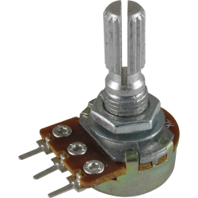
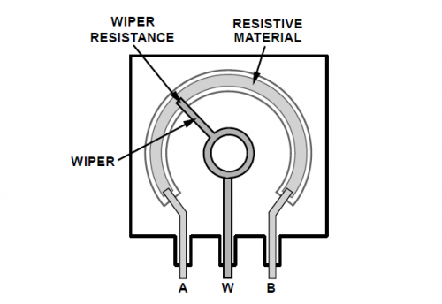
Potentiometers are usually equipped with 3 Pins. Two (generic the outer ones) span over the nominal value of the Pot. The third one (generic the center one) is linked to a Pickup Shoe (or Wiper) which moves depending of turning angle over the whole span of the Resistor. This Pickup is to connect to one of the analog Inputs, while the other two Pins are to connect to 5V and GND. So “occures” a Pickoff-Voltage from 0 to 5V, representing the Turning Angle. Arduino converts this into a digital value between 0 and 256.

LEDs or Lamps
Due to the limited endurable load to the outputs of the AVR, it isn‘t a good idea, to connect any kind of consumer directly to these outputs.
Most versions of ICB provide one amplified output for connecting PWM-controlled Backlight. If you have to control one or more other notification lights, it is highly recommended to protect the Outputs by a amplifier.

To be continued.

